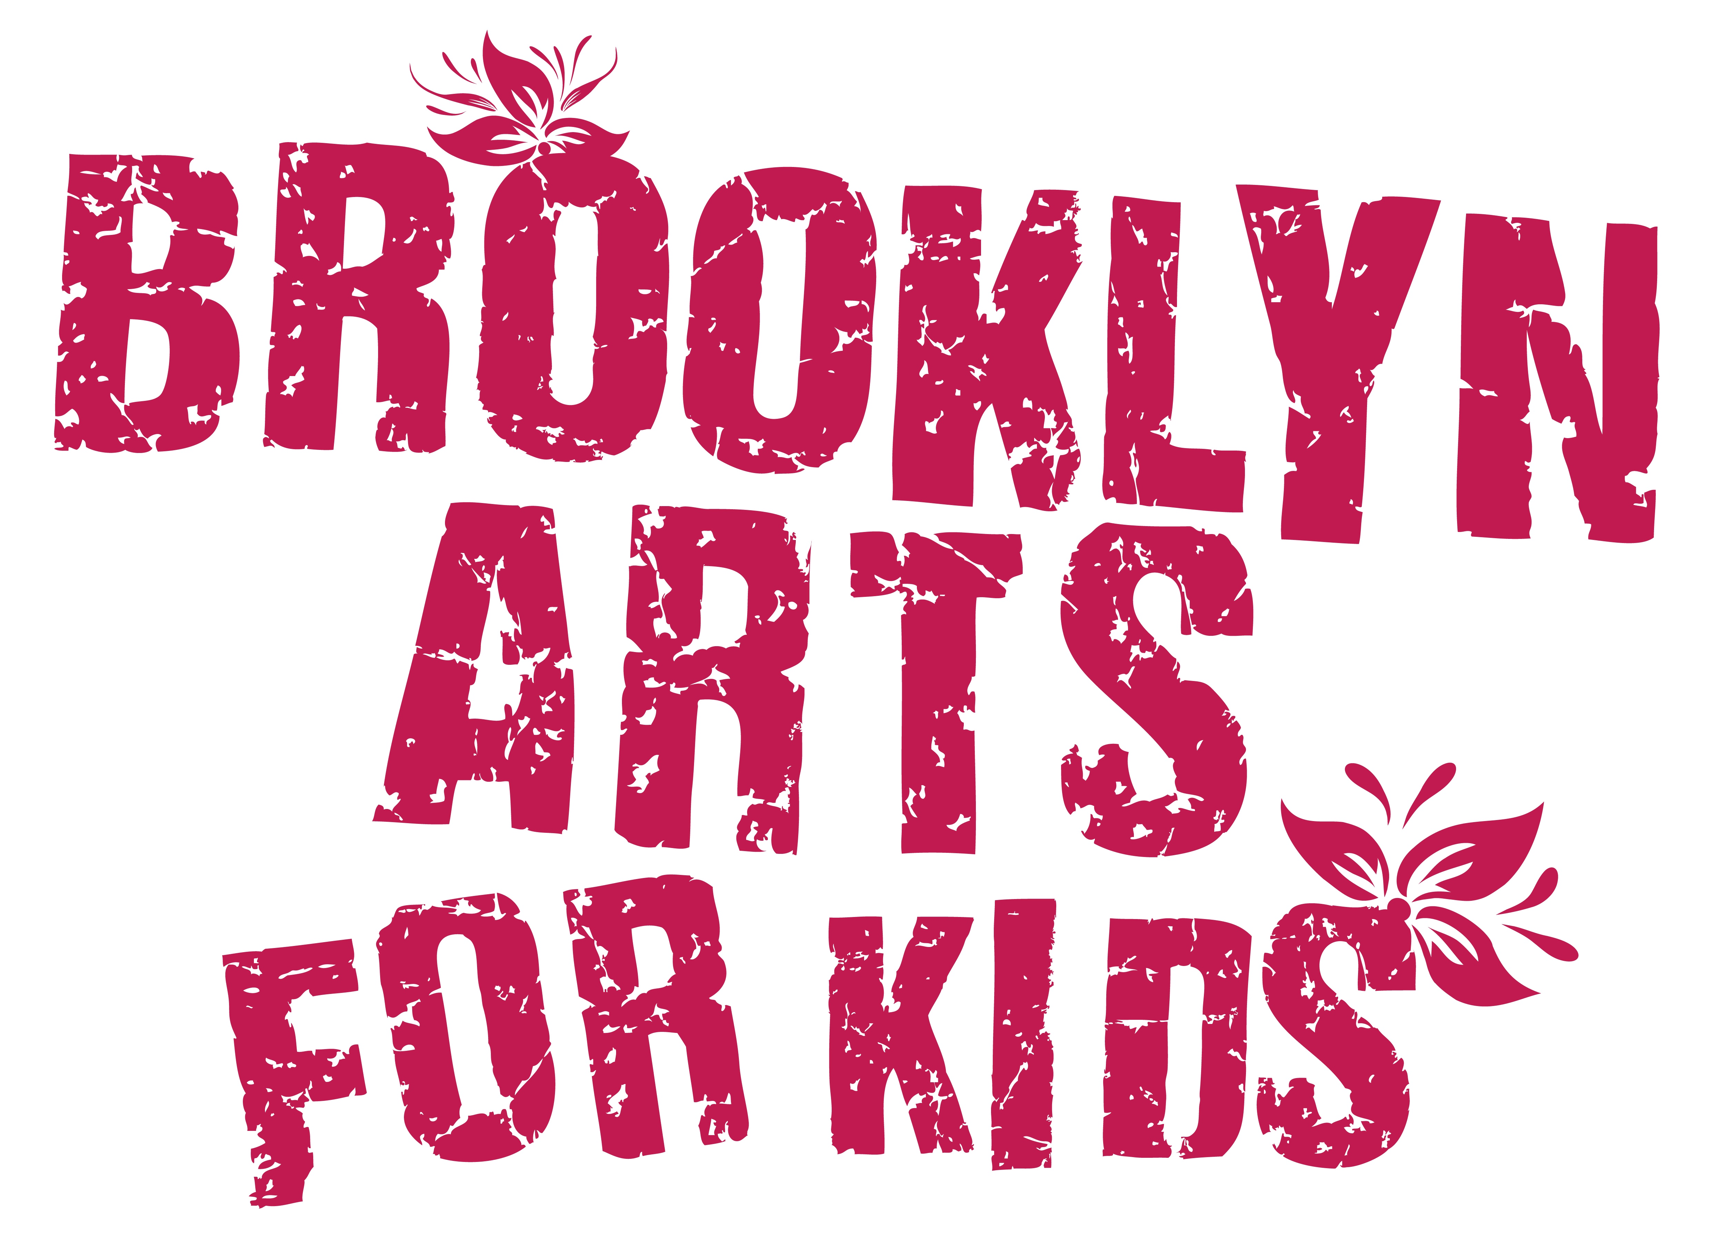
Summer Arts Experience
July 6th – 31st, 2020
Application
Date:
Young Artist’s Name:
Gender: Birth Date:
School: Current Grade:

Parent/Guardian Name:
Address:
Cell Number: Alt. Number:
Email address:

Parent/Guardian Name:
Address:
Cell Number: Alt. Number:
Email address:

Emergency Contact Person Info:
Name/Relation:
Phone:

Name of person(s) that would pick up your child other than you?
phone #
phone #

Any allergies, medications or other physical concerns?

How does your child best express her or himself?

What else do they enjoy?

How can we work most successfully with your child?

What else would you like us to know?

Special grouping-with-friend request?

What size t-shirt? (circle one) Kids: XS, S, M, L or Adult: S, M

Are you interested in an extended day? If yes, how many days a week? Open til 5pm.
How did you hear about us? □ friend □ flyer □ online □ __________
WHEN: July 6th – 31st, 2020 9:00am – 4:00pm, Monday – Friday. Drop-off: 8:45am - 9:00am (Look for the Earth flag!)
Pick-up: 4:00pm
Location: 16th St. & Prospect Park Southwest entrance to Prospect Park Public Transportation: F or G trains to 15th Street – Prospect Park station

WILL YOUR CHILD JOIN US IN-PERSON or ONLINE? _________

WHAT WEEK(S) WILL YOUR CHILD ATTEND?
(check each week) □ from July 6 – 10
□ from July 13 – 17
□ from July 20 – 24
□ from July 27 – 31

TUITION FOR IN-PERSON ARTSCAMP:
□ one week = $600
□ two weeks = $1,120 ($80 off)
□ three weeks = $1,720 ($80 off)
□ four weeks = $2,220 ($180 off)
TUITION FOR ONLINE ARTSCAMP:
□ $300 for each week
then PLEASE
□ Add $50 for t-shirt, materials & registration fee.
TOTAL $______________
TO RESERVE A SPACE: Complete an application and send full payment in check or money order made out to Belinda Blum to: 196 New York Avenue #3, Brooklyn, New York 11216
OR PAY BY – Zelle @ 917-326-0867 or CashApp @ $ebwally18
CANCELLATION POLICY: Refunds are available minus a $50 fee.

REQUESTS: Children should be dressed in comfortable clothing and supplied with lunch, water, hat, mask and sunscreen, if necessary.

PHOTOS/VIDEO: With your permission, young artists will be photographed or recorded by BAK for promotional purposes.

PLEASE NOTE: We have been amazed year after year to see the magic that happens when kids open themselves up to the art-making process and to working together as an ensemble. This process depends on kids who are committed to following instructions and working collaboratively with others. Please contact us if you want to discuss further whether this experience would be right for your child.

PARTICIPANT AGREEMENT, RELEASE AND ASSUMPTION OF RISK In consideration of the services of Belinda Blum, Eric “Wally” Wallach and Brooklyn Arts for Kids (BAK), I hereby agree to release, indemnify and discharge them on behalf of my children and myself as follows: 1. I acknowledge that my child’s participation in Brooklyn Arts for Kids entails known and unanticipated risks that could result in physical or emotional injury to oneself or to third parties. 2. I hereby release, forever discharge, and agree to indemnify and hold harmless BAK from any and all claims, demands or cause of action, which are in any way connected to my child’s participation in BAK. 3. I further certify that I am willing to assume the risk of any medical or physical condition that my child may have. 4. I do hereby give permission to BAK to obtain the necessary emergency medical treatment for my child, with the understanding that the family is notified as soon as possible. If my child receives an injury during BAK, I am responsible for any medical expenses incurred. 5. BAK is not responsible for damage to or loss of personal property.

By signing this document, I acknowledge that if anyone is hurt or property is damaged during my child’s participation in BAK, I may be found by a court of law to have waived my right to maintain a lawsuit against Blum, Wallach or BAK on the basis of any claim from which I have released them herein. I have had sufficient opportunity to read this entire document. I have read and understood it and I agree to be bound by its terms.

Parent Signature Print name: _______________

Thank you!
We look forward to working with your young artist this summer.
Belinda’s number is 917-326-0867. Wally’s number is 917-907-0701.

