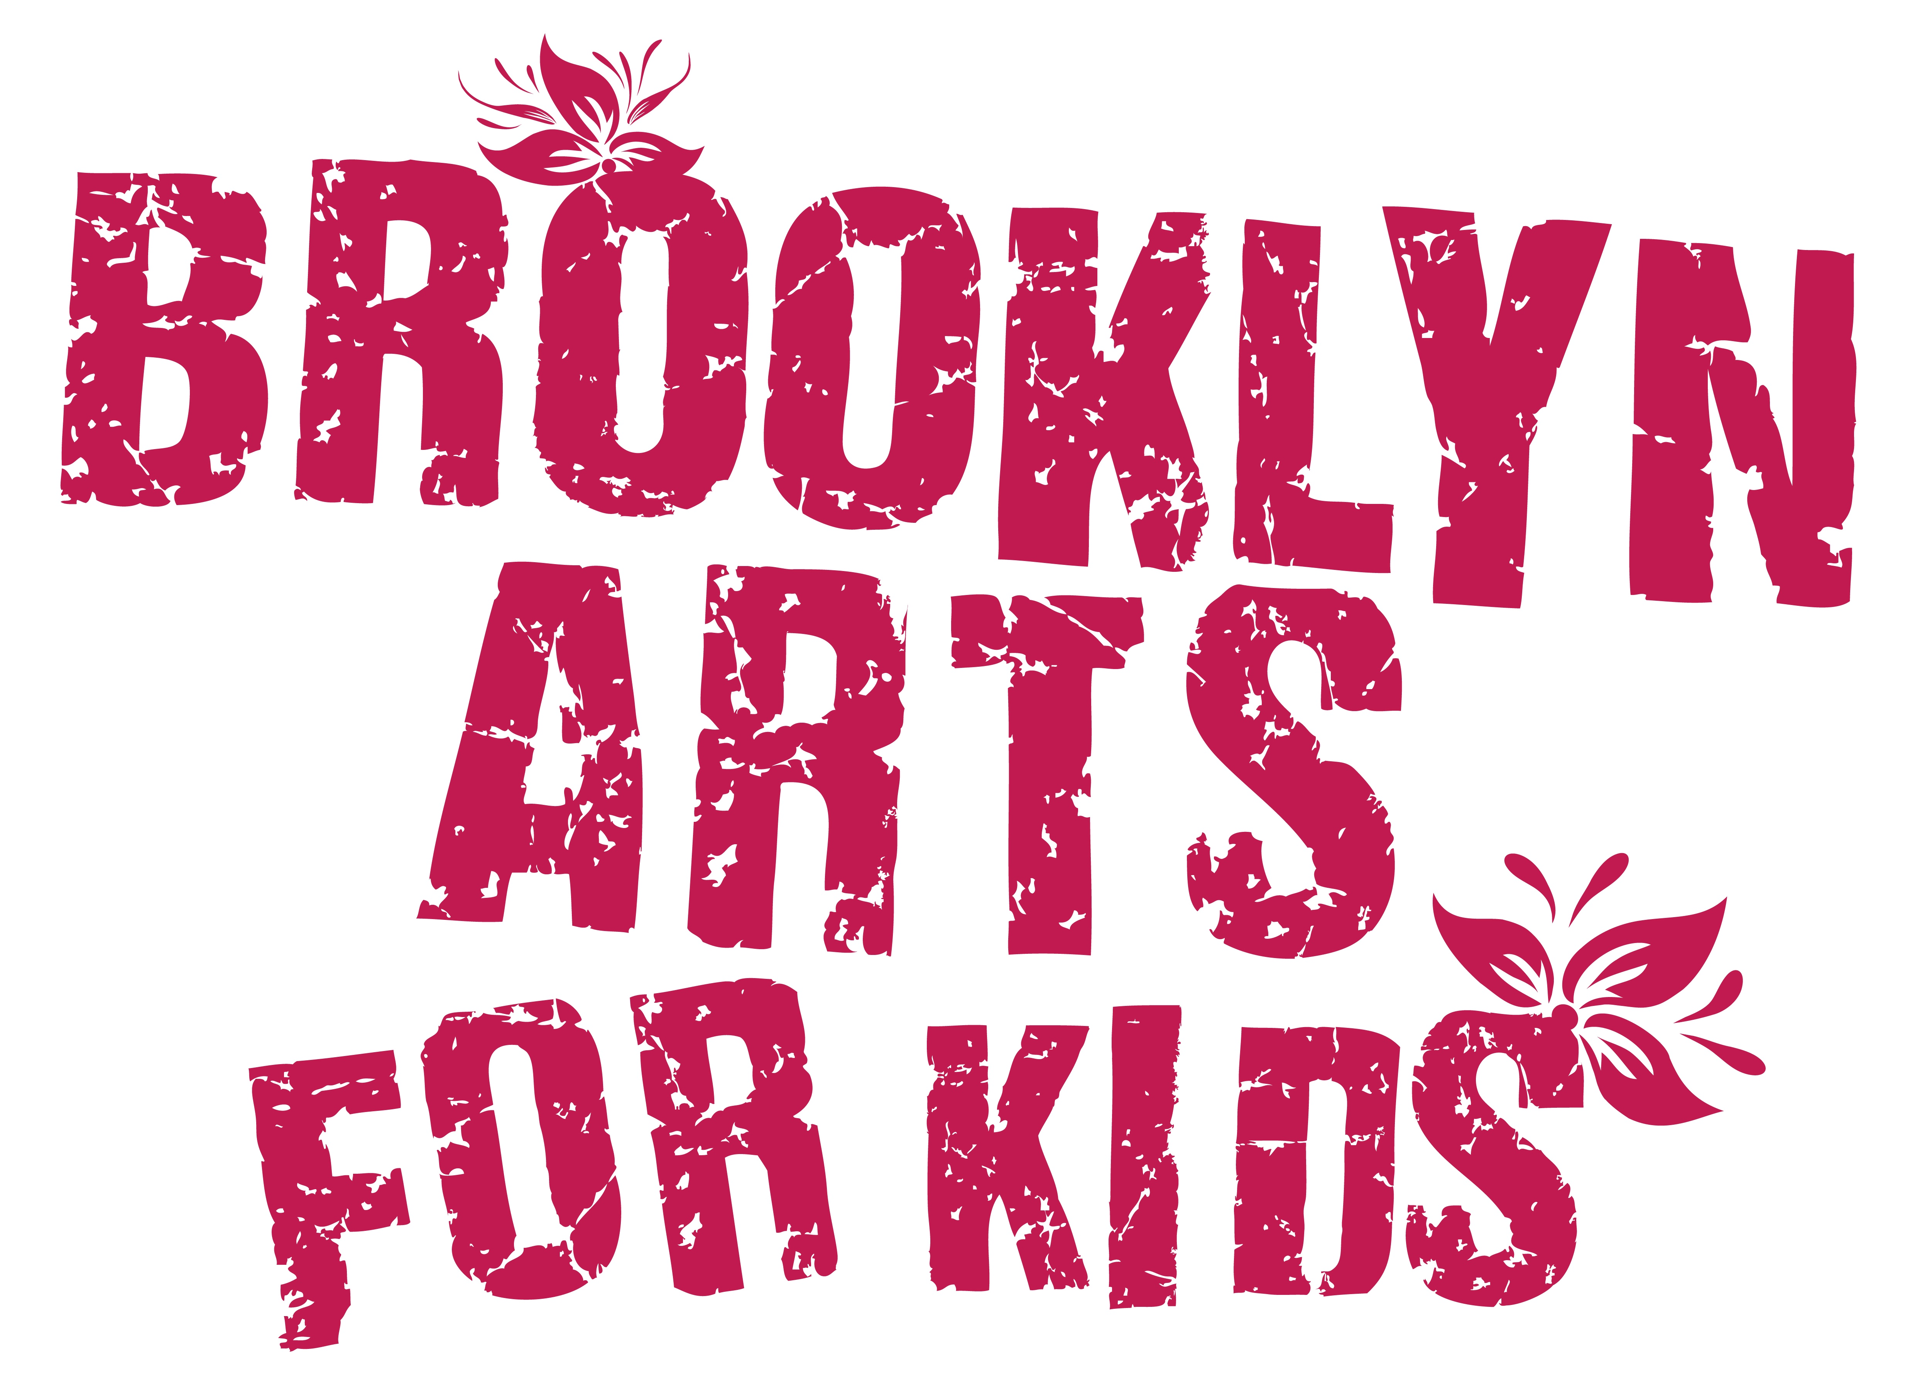
Winter Fundays 2023
Application
FUNDAYS begin Sunday, January 16
and continue Sundays to March 12.

Date:

Artist’s Name:
Birth Date: Gender Identity:
Address:
Cell Number: Alternative Number:
Email address:
School: Current Grade:

Artist #2’s Name:
Birth Date: Gender Identity:
Address:
Cell Number: Alternative Number:
Email address:
School: Current Grade:

Parent/Guardian Name:
Cell Number: Alternative Number:
Email address:

Emergency Contact Person Info:
Name/Relation:
Phone:

Name of person(s) that would pick up your child other than you?
phone #
phone #

How did you hear about us? □ friend □ online □ ___________

What kind of scene are you interested in exploring?
□ original □ musical □ Film □ Shakespeare □ __________

TIMING:

Ensemble A meets from 2:15pm to 4:00pm.

If/when we have six pairs for Ensemble A’s time, we will form Ensemble B.
Minimum 12 people, maximum 18.
Ensemble B meets from 4:15pm to 6:00pm.

What is your availability and preference? When will you begin?
Ensemble A?
Ensemble B?

Location: Park Slope Jewish Center, 1320 8th Ave, Brooklyn, NY 11215

Public Transportation: F or G trains to 15th Street/Prospect Park station

COST:

FUNDAYS begin January 16 and continues Sundays indefinitely.

□ $420 per pair for three (3) Fundays
□ $160 per pair for each additional Fundays

then PLEASE

□ Add $30 for materials & registration fee.
TOTAL $______________
TO RESERVE A SPACE: Complete an application and send payment by check or money order made out to FLIGHT18
to 196 New York Avenue #3, Brooklyn, New York 11216
OR PAY BY – CashApp @ $ebwally18 OR PAY BY CASH IN ADVANCE
CANCELLATION POLICY: Refunds are available minus a $50 fee.

PHOTOS/VIDEO: With your permission, artists will be photographed or recorded by BAK for promotional purposes.

PARTICIPANT AGREEMENT, RELEASE AND ASSUMPTION OF RISK In consideration of the services of Eric “Wally” Wallach and Brooklyn Arts for Kids (BAK), I hereby agree to release, indemnify and discharge them on behalf of my children and myself as follows: 1. I acknowledge that my child’s participation in Brooklyn Arts for Kids entails known and unanticipated risks that could result in physical or emotional injury to oneself or to third parties. 2. I hereby release, forever discharge, and agree to indemnify and hold harmless BAK from any and all claims, demands or cause of action, which are in any way connected to my child’s participation in BAK. 3. I further certify that I am willing to assume the risk of any medical or physical condition that my child may have. 4. I do hereby give permission to BAK to obtain the necessary emergency medical treatment for my child, with the understanding that the family is notified as soon as possible. If my child receives an injury during BAK, I am responsible for any medical expenses incurred. 5. BAK is not responsible for damage to or loss of personal property.

By signing this document, I acknowledge that if anyone is hurt or property is damaged during my child’s participation in BAK, I may be found by a court of law to have waived my right to maintain a lawsuit against Blum, Wallach or BAK on the basis of any claim from which I have released them herein. I have had sufficient opportunity to read this entire document. I have read and understood it and I agree to be bound by its terms.

Signature(s) Print name(s): ______________

Signature(s) Print name(s): ______________

Thank you!
Looking forward to having fun with you,

Wally

917-907-0701 ebwally@gmail.com www.ebwally.com
www.brooklynartsforkids.com

