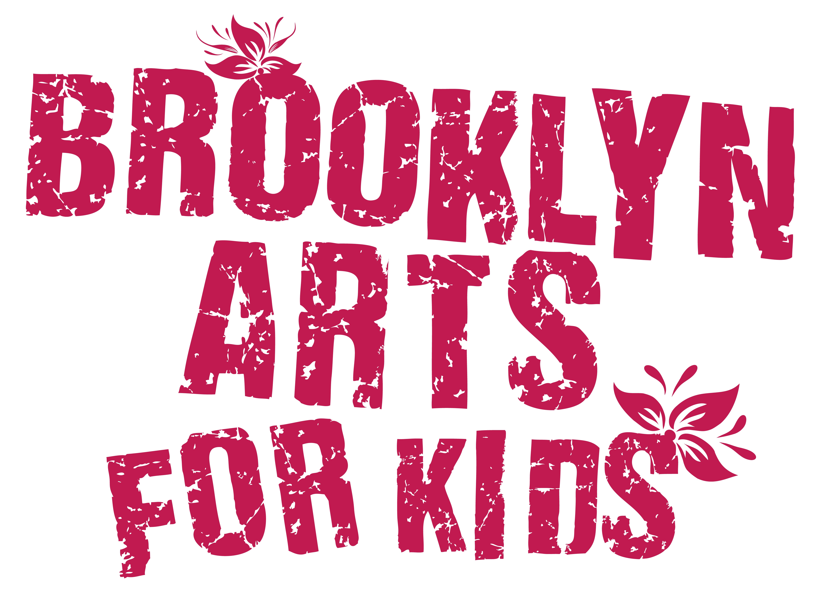
Summer Arts Experience
July 10th – 28th, 2023
Application

Date:
Young Artist’s Name:
Preferred pronouns: Birth Date:
School: Current Grade:

Parent/Guardian Name:
Address:
Cell Number: Alt. Number:
Email address:

Parent/Guardian Name:
Address:
Cell Number: Alt. Number:
Email address:

Emergency Contact Person Info:
Name/Relation:
Phone:

Name of person(s) that would pick up your child other than you?
phone #
phone #

Any allergies, medications, or other physical concerns?

How does your child best express themself?

What else do they enjoy?

How can we work most successfully with your child?

What else would you like us to know?

Special grouping-with-friend request?

What size t-shirt? (circle one) Kids: XS, S, M, L or Adult: S, M

How did you hear about us? □ friend □ online □ __________
Monday – Friday
Drop-off: 8:45am - 9:00am Pick-up: 4:00pm
Location: Park Slope Jewish Ctr, 1320 8th Ave, Brooklyn, 11215

WHAT WEEK(S) WILL YOUR CHILD ATTEND?
(check each week) □ July 10 – 14
□ July 17 – 21
□ July 24 – 28
TUITION FOR SUMMER ARTSCAMP:
□ one week = $675
□ two weeks = $1,300 ($50 off)
□ three weeks = $1,925 ($100 off)
then PLEASE
□ Add $50 for t-shirt, materials & registration fee
TOTAL $______________

PLEASE CHECK HOW YOU ARE PAYING YOUR BALANCE:
When using electronic payment, please include ONLY the name of your young artist(s) in the memo.
□ through Zelle: # 9173260867
□ through Venmo: @Belinda-Blum
□ through CashApp: $ebwally18
□ by check made out to Belinda Blum and mailed to: Belinda Blum, 196 New York Avenue #3, Brooklyn, NY 11216 □ by cash
CANCELLATION POLICY: Full refunds will be available prior to June 1. Half refunds are available until June 25. Registrations cancelled after July 7 will not be refunded. The $50 registration fee is non-refundable.

REQUESTS: Children should be dressed in comfortable clothing and supplied with lunch, water, hat, mask, and sunscreen, if necessary.

PHOTOS/VIDEO: With your permission, young artists will be photographed or recorded by BAK for promotional purposes.

PLEASE NOTE: We have been amazed year after year to see the magic that happens when kids open themselves up to the art-making process and to working together as an ensemble. This process depends on kids who are committed to following instructions and working collaboratively with others. Please contact us if you want to discuss further whether this experience would be right for your child.

PARTICIPANT AGREEMENT, RELEASE AND ASSUMPTION OF RISK In consideration of the services of Belinda Blum, Eric “Wally” Wallach and Brooklyn Arts for Kids (BAK), I hereby agree to release, indemnify and discharge them on behalf of my children and myself as follows: 1. I acknowledge that my child’s participation in Brooklyn Arts for Kids entails known and unanticipated risks that could result in physical or emotional injury to oneself or to third parties. 2. I hereby release, forever discharge, and agree to indemnify and hold harmless BAK from any and all claims, demands or cause of action, which are in any way connected to my child’s participation in BAK. 3. I further certify that I am willing to assume the risk of any medical or physical condition that my child may have. 4. I do hereby give permission to BAK to obtain the necessary emergency medical treatment for my child, with the understanding that the family is notified as soon as possible. If my child receives an injury during BAK, I am responsible for any medical expenses incurred. 5. BAK is not responsible for damage to or loss of personal property.

By signing this document, I acknowledge that if anyone is hurt or property is damaged during my child’s participation in BAK, I may be found by a court of law to have waived my right to maintain a lawsuit against Blum, Wallach or BAK on the basis of any claim from which I have released them herein. I have had sufficient opportunity to read this entire document. I have read and understood it and I agree to be bound by its terms.

Parent Signature Print name: _______________

Thank you!
We look forward to working with your young artist, Summer ’23!
Wally’s number is 917-907-0701
E-mail brooklynartsforkids@gmail.com

